**Lebanese American University**

**School of Engineering**



**Microprocessors**

**COE 324 – Section 32**

*Mr. Nicolas Jamal*

**Final Project**

*Edwin Odeimi 201601044*

*Walid Aboul Hosn 201500704*

*Melissa Abboud 201401538*

*December 3rd, 2018*

Table of Contents

Task1 5

Task2 7

Task3 8

Task4 + Bonus 10

Some Explanations 11

References 15

Table of Figures

Figure 1 Push buttons connections to J1 5

Figure 2 SW1 & SW2 configuration code sample 5

Figure 3 PB1 -> PB6 configuration code sample 5

Figure 4 PB step diagram 6

Figure 5 Pot step diagram 7

Figure 6 Ultrasonic sensor connections to J1 8

Figure 7 ATD configuration code sample 8

Figure 8 US step diagram 9

Figure 9 Project diagram 10

Figure 10 Potentiometer value normalization diagram 11

Figure 11 Ultrasonic sensor value normalization diagram 12

Figure 12 LEDs diagram 14

Figure 13 LEDs code sample 14

Table of Tables

Table 1 Step Table 13

# Task1

First, we must configure the buttons:

* 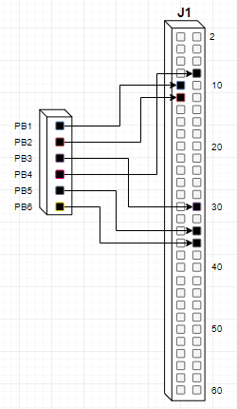PB1 🡺 PP0

Figure 1 Push buttons connections to J1

* PB2 🡺 PP1
* PB3 🡺 PP2
* PB4 🡺 PP7
* PB5 🡺 PP4
* PB6 🡺 PP5

Their configuration is very similar to the push buttons on the microprocessor board except for replacing every #$03 with #$B7 to enable the pins on J1 instead of SW1 and SW2.

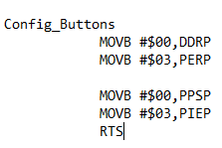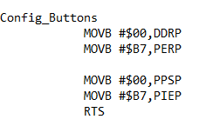To explain the PB step:

Figure 2 SW1 & SW2 configuration code sample

Figure 3 PB1 -> PB6 configuration code sample

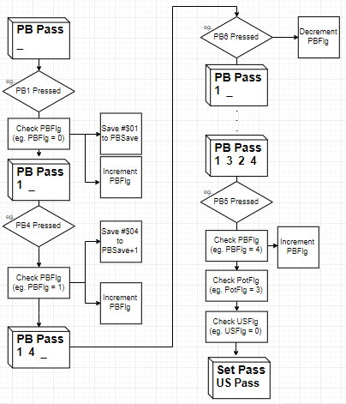NB: The login PB step is the same except for the flag (PassSetFlg) that indicates we are in the login.

Figure 4 PB step diagram

# Task2

The potentiometer configuration is the same as Lab 7. As for the potentiometer step:

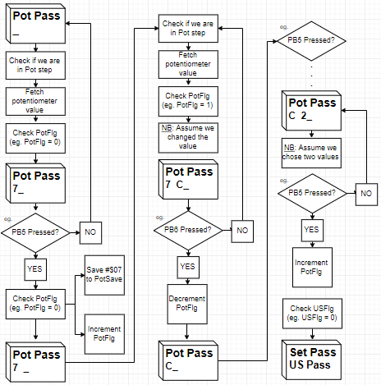NB: The login Pot step is the same except for the flag (PassSetFlg) that indicates we are in the login.

Figure 5 Pot step diagram

# Task3

First, we must configure the ultrasonic sensor:

* 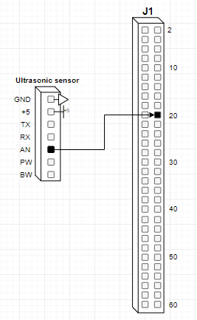AN 🡺 AN01

Figure 6 Ultrasonic sensor connections to J1

The configuration is very similar to the potentiometer configuration except for sending #$21 to ATD0CTL5 instead of #$25, because we are setting scan mode on AN01 instead of AN05. We also need to read the value from the register ATD0DR1H instead of ATD0DR5H.

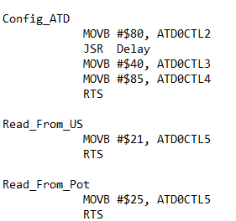

Figure 7 ATD configuration code sample

To explain the US step:

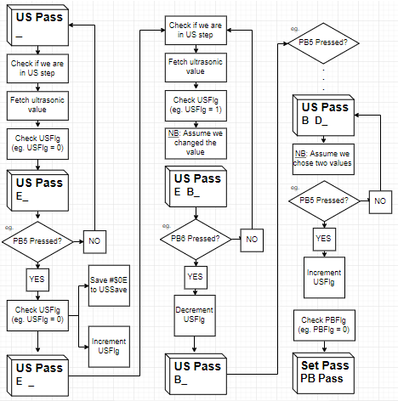NB: The login US step is the same except for the flag (PassSetFlg) that indicates we are in the login.

Figure 8 US step diagram

# Task4 + Bonus

Now to put together the whole project:

Figure 9 Project diagram

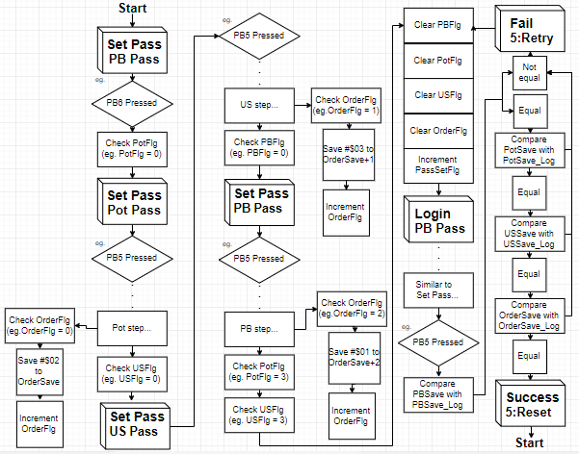

# Some Explanations

1. 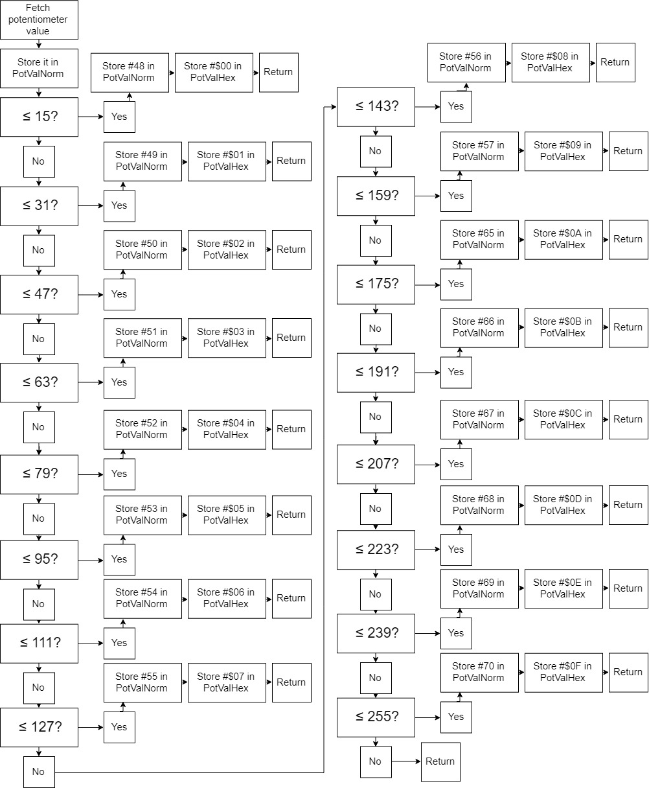Normalizing the potentiometer value from 0 🡺 255 to 0 🡺 F:

Figure 10 Potentiometer value normalization diagram

1. Normalizing the ultrasonic sensor value from 4 🡺 8 to A 🡺 E:

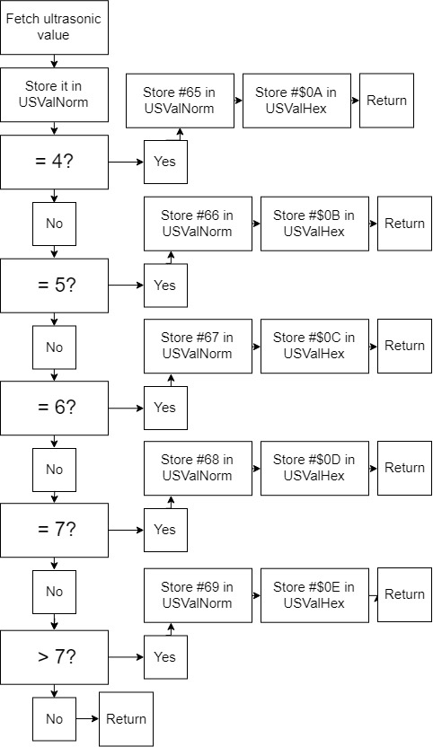

Figure 11 Ultrasonic sensor value normalization diagram

1. The project is divided into 14 steps illustrated in the step table below:

Table 1 Step Table

|  |  |
| --- | --- |
| **Step No(Hex)** | **Step Description** |
| $00 | Set Pass, PB Pass |
| $01 | Set Pass, Pot Pass |
| $02 | Set Pass, US Pass |
| $03 | PB Pass Registration |
| $04 | Pot Pass Registration |
| $05 | US Pass Registration |
| $06 | Login, PB Pass |
| $07 | Login, Pot Pass |
| $08 | Login, US Pass |
| $09 | PB Pass Check |
| $0A | Pot Pass Check |
| $0B | US Pass Check |
| $0C | Failed Authentication |
| $0D | Succeeded Authentication |

1. 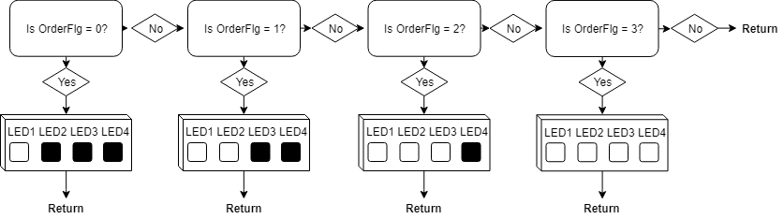The LEDs light up in a certain way depending on the step. We used OrderFlg to know at which step we are since it only changes once a step is completed:

Figure LEDs diagram

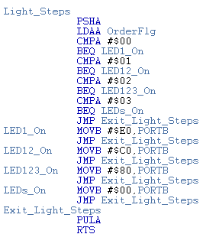

Figure LEDs code sample

# References

APS12OS User Guide

MC9S12DT256 Device User Guide (MC9S12DT256.pdf)

MC3S12RG128 Data Sheet (Interrupt Registers Reference.pdf)

Axiom Manufacturing: schematic CSMB12D AXM-0436

MC9S12XS256 Reference Manual

CPU 12 Reference Manual